Installation

Since application is in Node js first install node

<https://nodejs.org/en/download/>

To run application, download it from github:

<https://github.com/spica29/friapp/tree/master/project%202>

In Windows locate console with Powershell in the folder /project 2/project and install dependencies with command:

**npm install**

Instal mysql server and workbench, and create schema with name „wpdb“ and credentials: username: „root“ password:““ (empty). Then import code from /project/db.sql (in the picture database will be instead of export.sql -> db.sql:

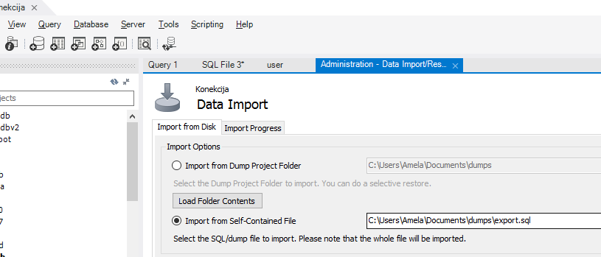

Run node application in PowerShell located in /project 2/project

**npm start**

Node js will open application on localhost with port 3000, so open localhost:3000 in web browser and that is it.